B.R TECH

**Submitted to: PROF. WAQAS SALEEM**

Abstract

**Assignment: Git, Gitea, GitHub, LFS, and GitHub Pages**

CLOUD COMPUTING

CC ASSIGNMENT 1

**SUBMITTED BY:** AROOBA REHMAN(BSE-012)

**SECTION: A**

Task 1: Run Gitea in Codespace and Create an Initial Repo  
  
1. Set up Gitea:  
   - Run a Gitea server inside your Codespace.  
   - Use HTTPS for communication (SSH is not supported in Codespace).

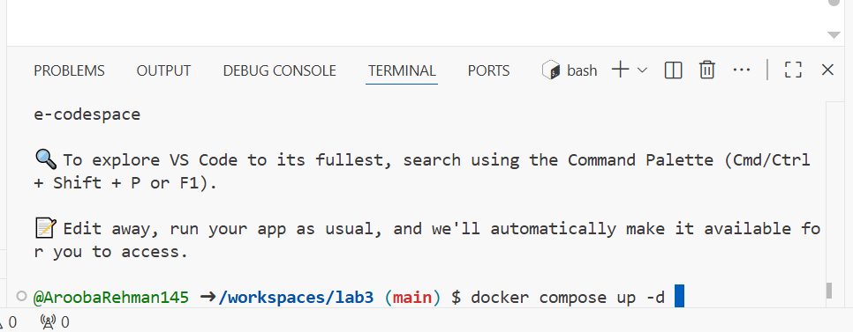

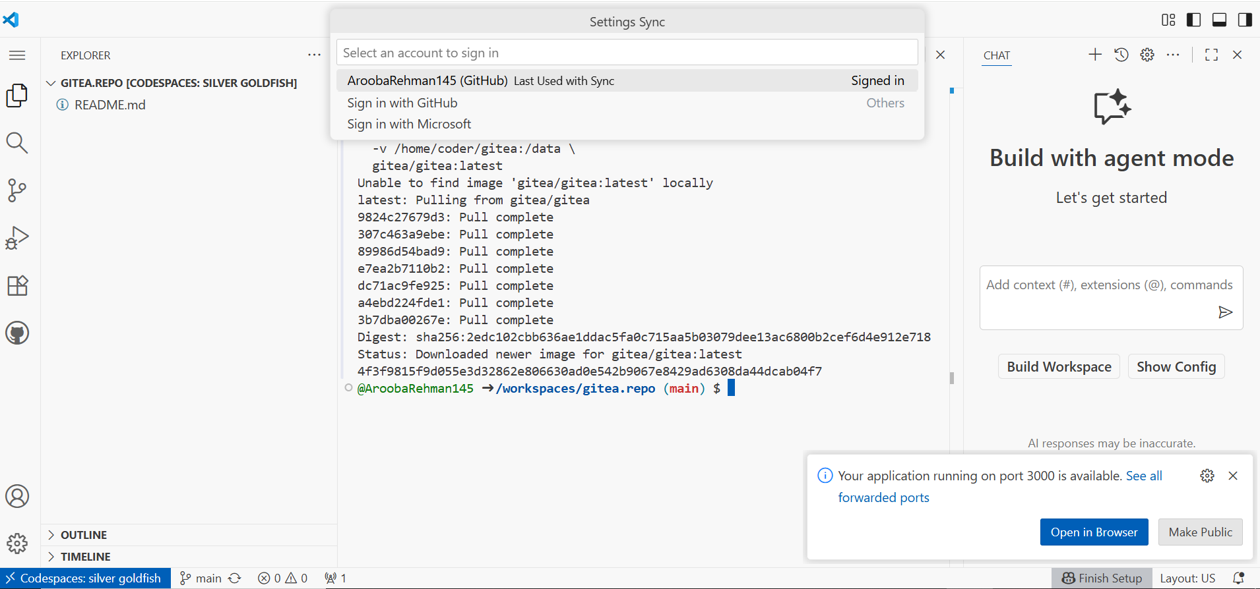

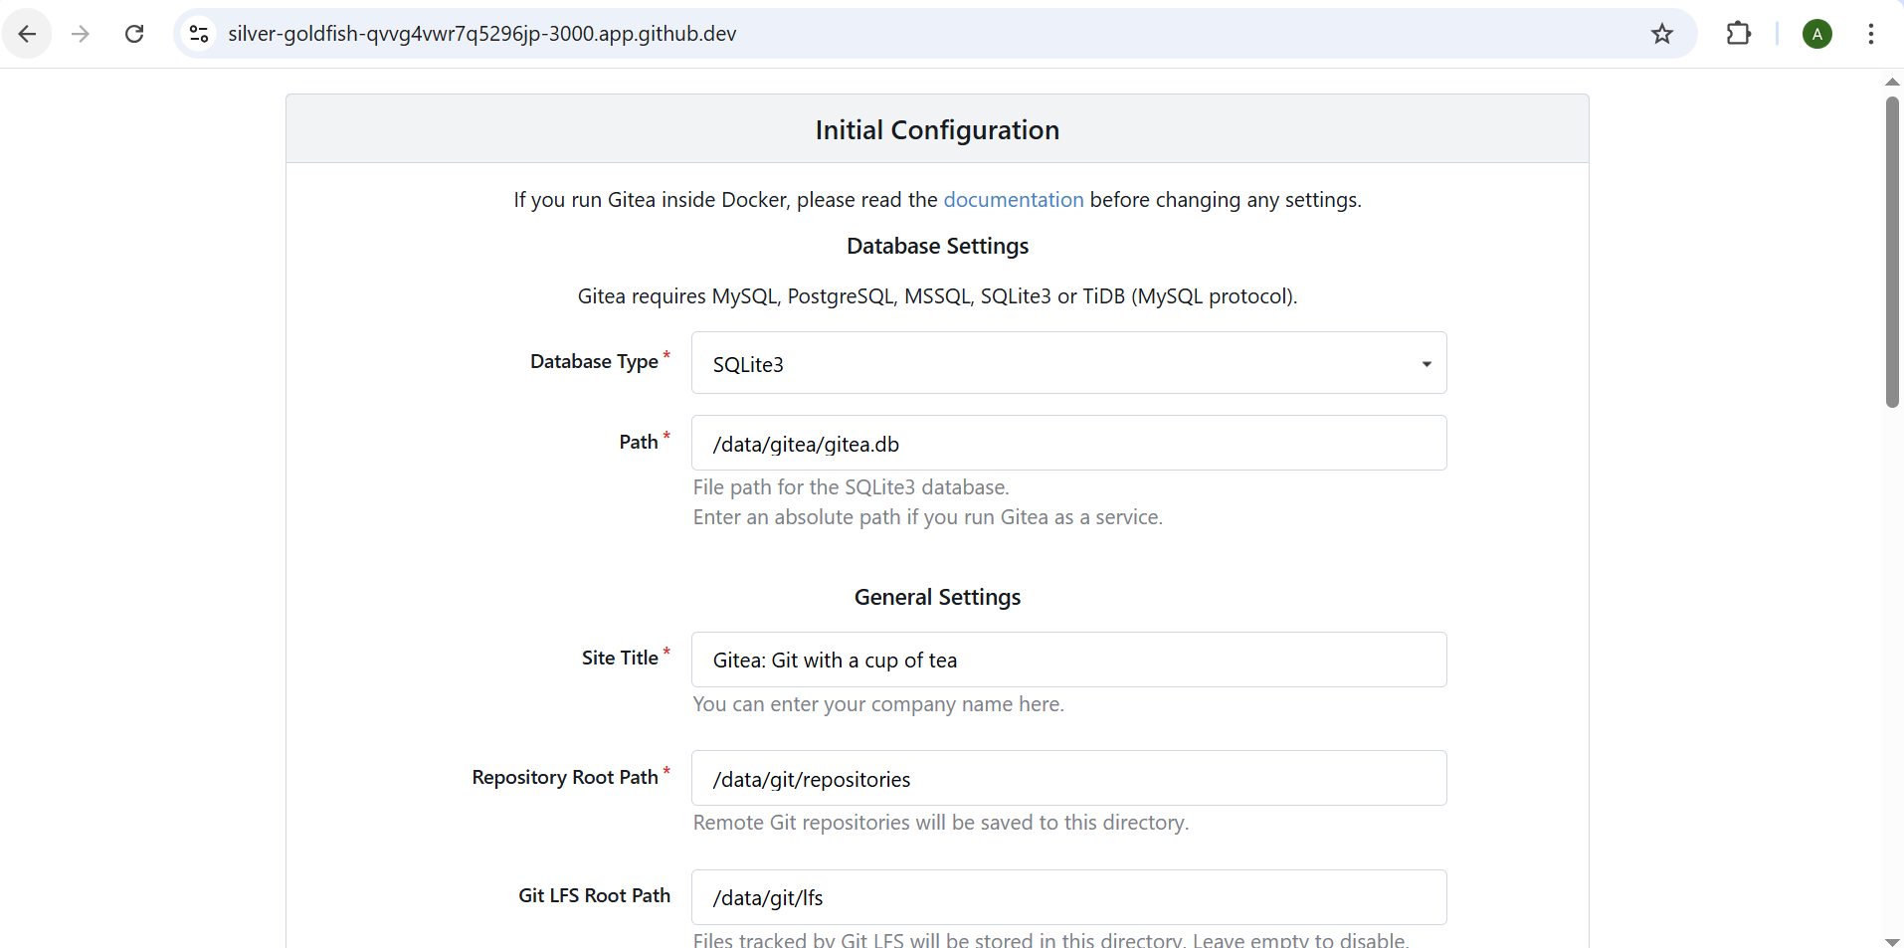

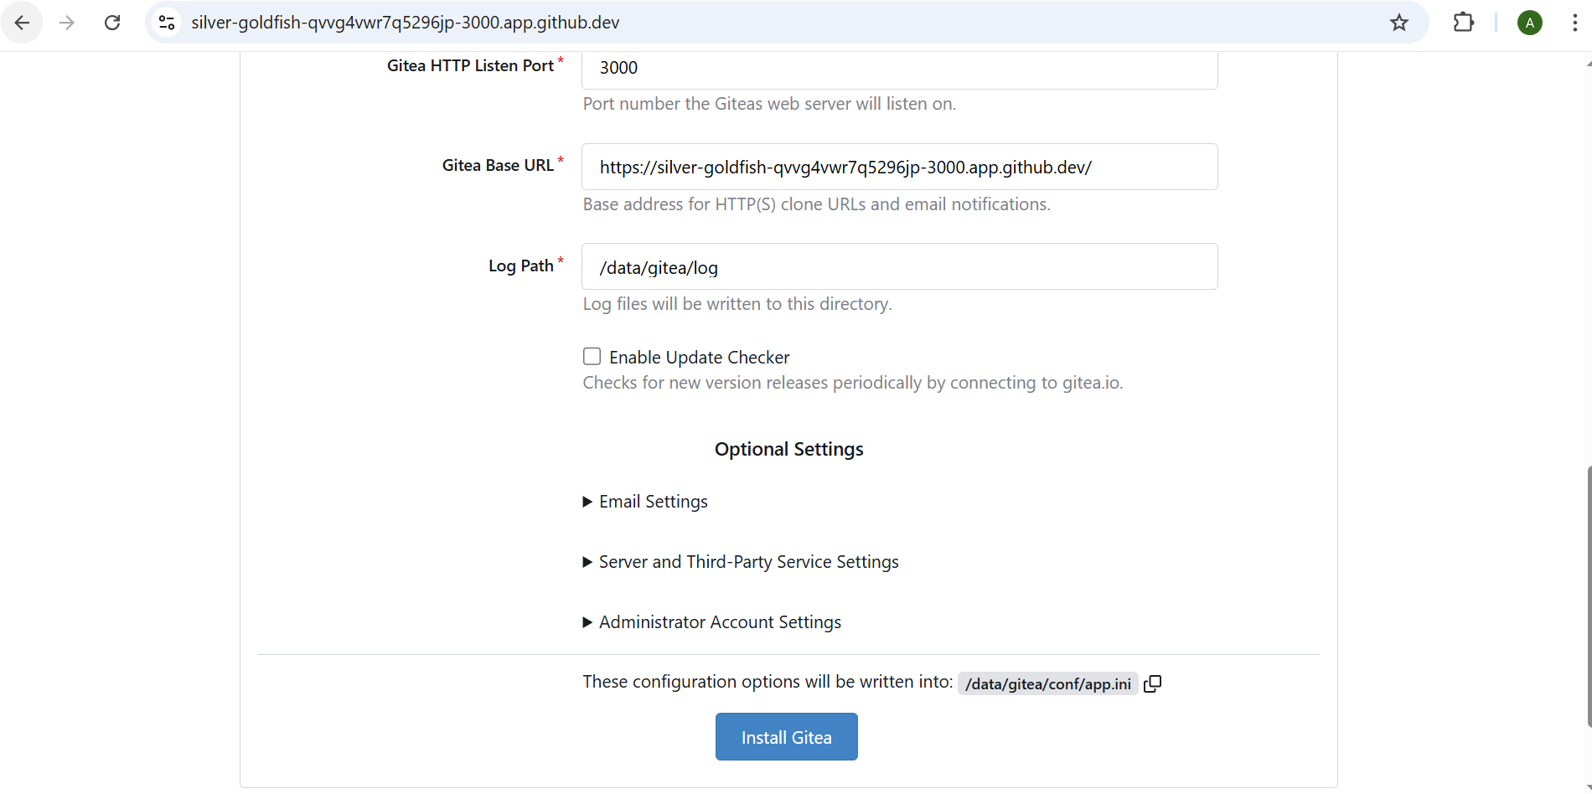

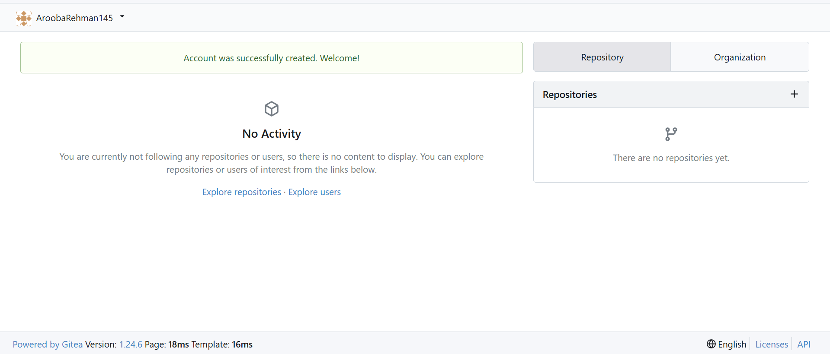

2. Create a Repository:  
   - Create a new repository on your Gitea server.  
   - Add a README.md file listing each student's name and roll number.

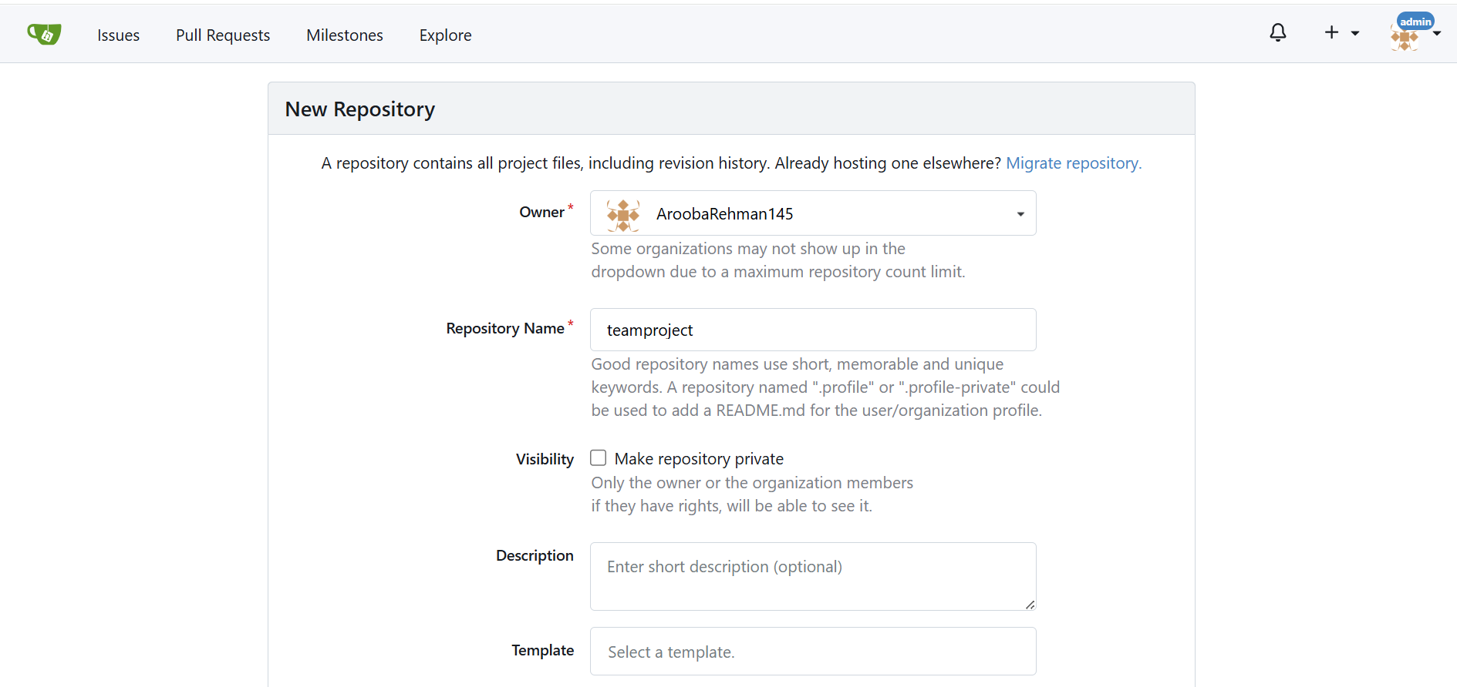

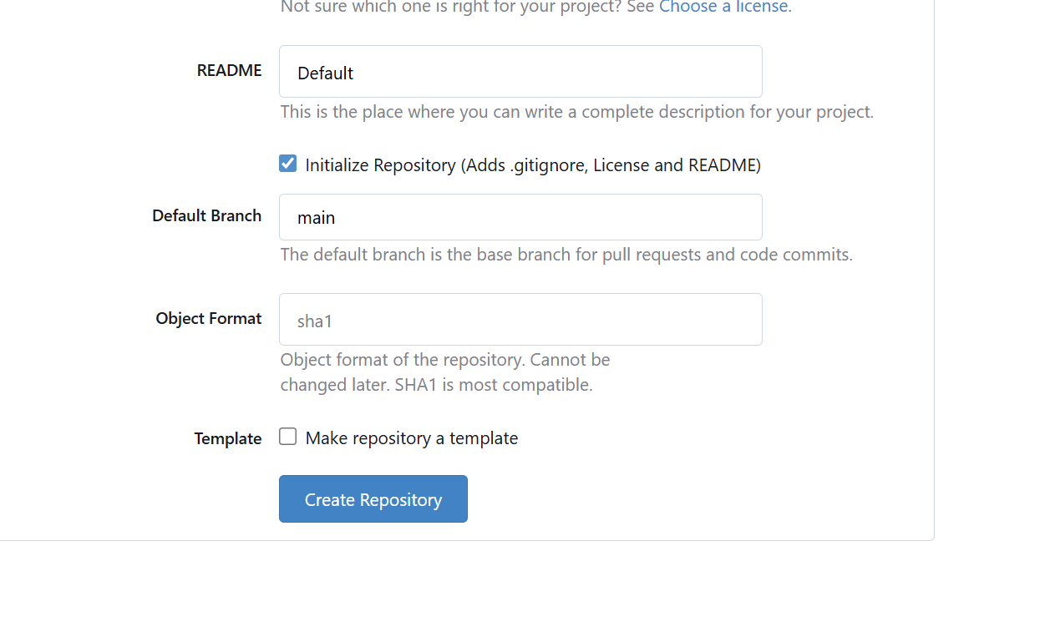

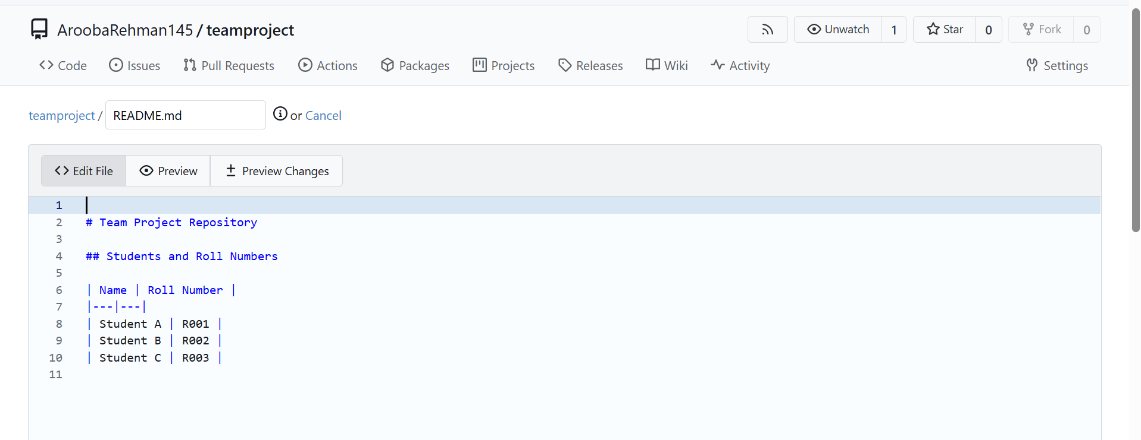

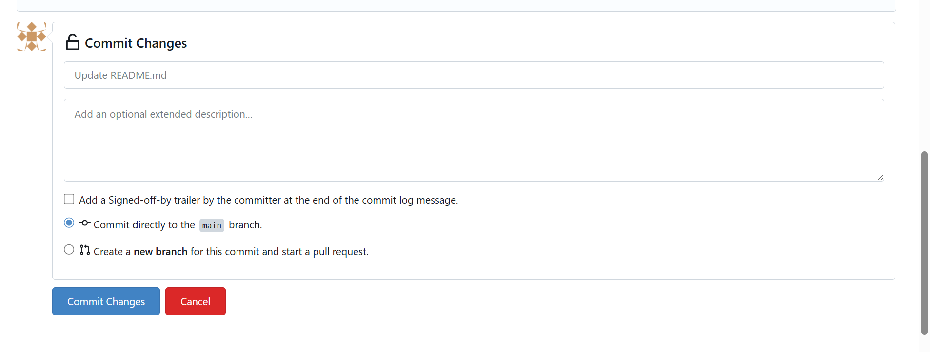

3. Add Remote Repo:  
   - Use the following command to add your Gitea repository as a remote:  
     git remote add gitea <your_gitea_repo_https_url>  
   - Push your initial commit containing the README.md to Gitea.

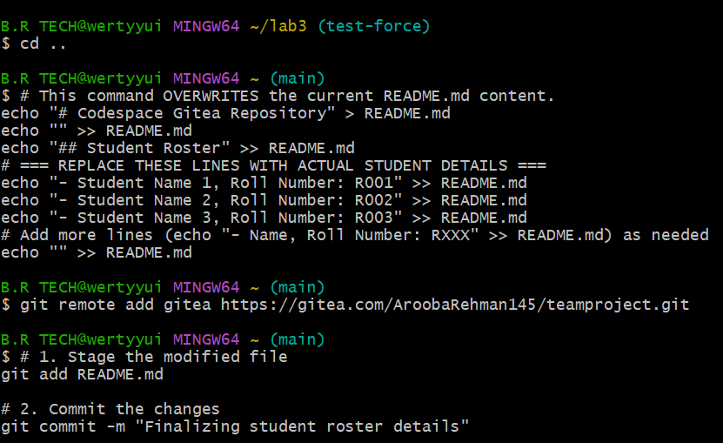

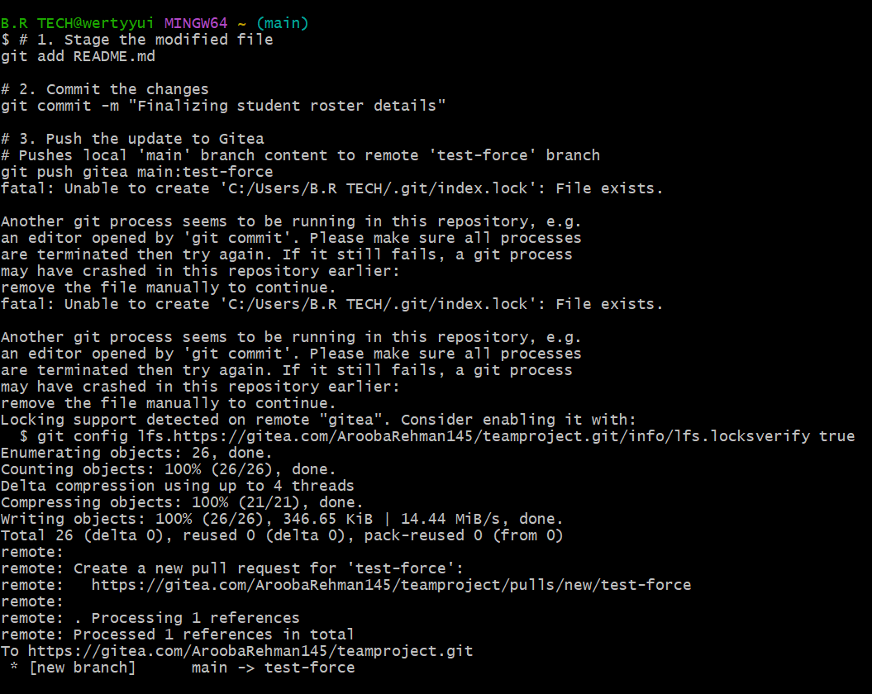

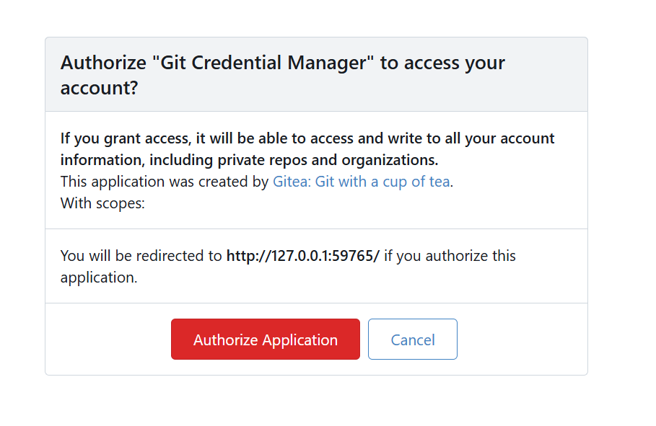

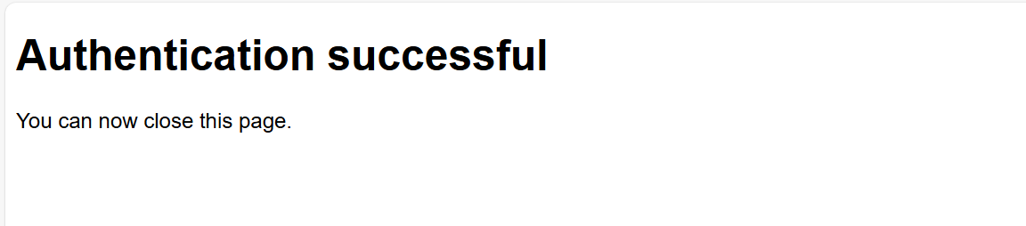



Task 2: Mirror README.md from Gitea to GitHub  
  
1. Continue Working with Your Existing Repository:  
   - You will use the same repository that you created and pushed to your Gitea server in Task 1.  
  
2. Create GitHub Repository:  
   - Create a new GitHub repository named assignment 1.

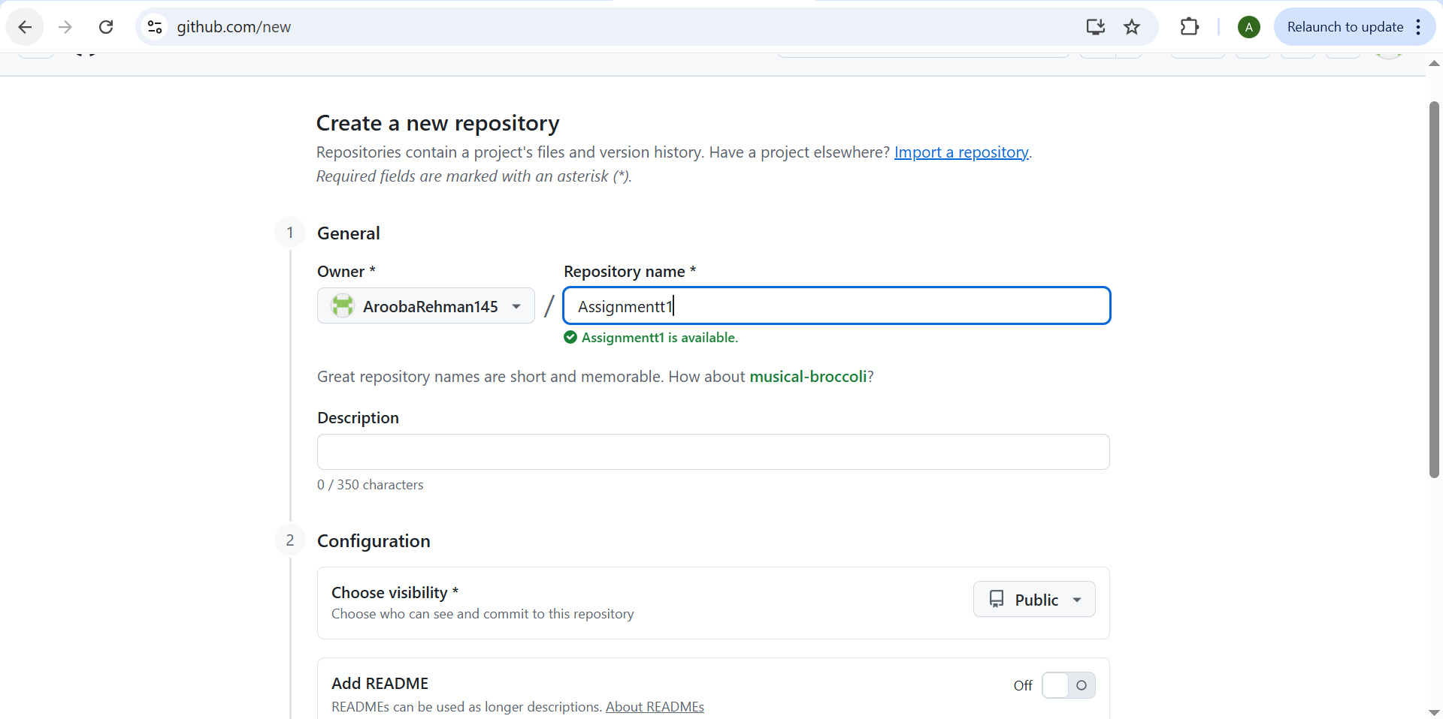

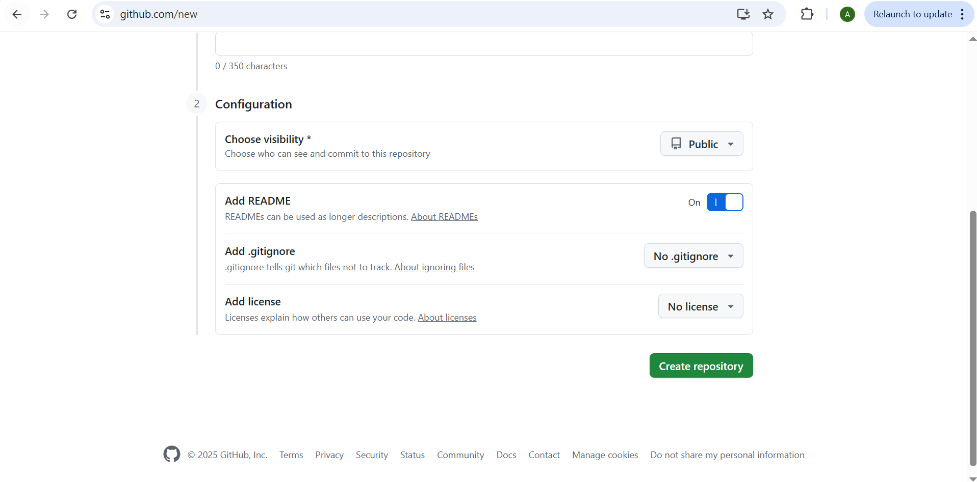

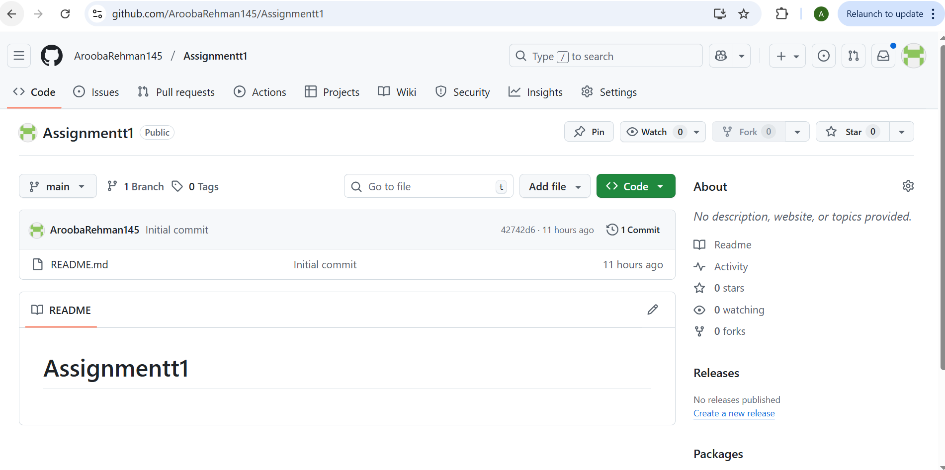

3. Add GitHub as a Second Remote:  
   - Add your GitHub repository as a remote to your local repository:  
     git remote add github <your_github_repo_https_url>



4. Push the README.md File to GitHub:  
   - Push the contents (including the README.md) from your local repository to GitHub.

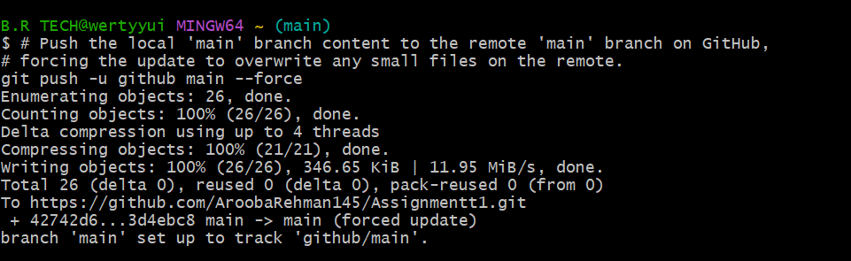

5. Verify Remotes:  
   - Run git remote -v and ensure both remotes (gitea and github) are listed.

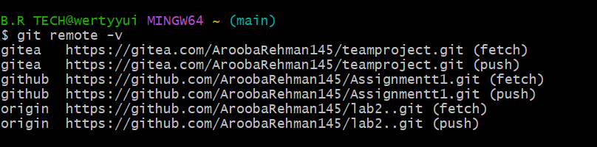

Task 3: Use Git LFS for Large Files

1. Install Git LFS:

   - Set up Git LFS in your local repository.

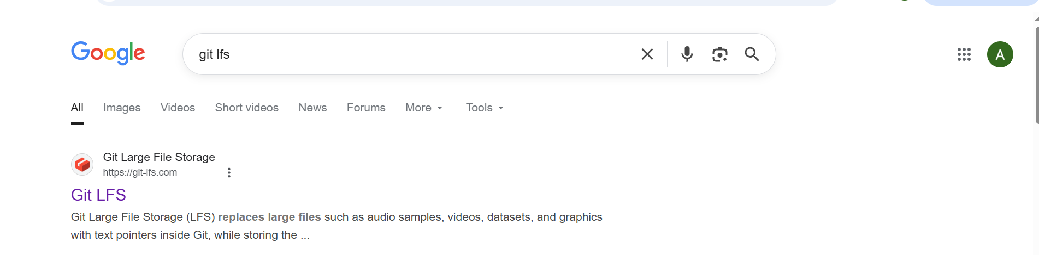

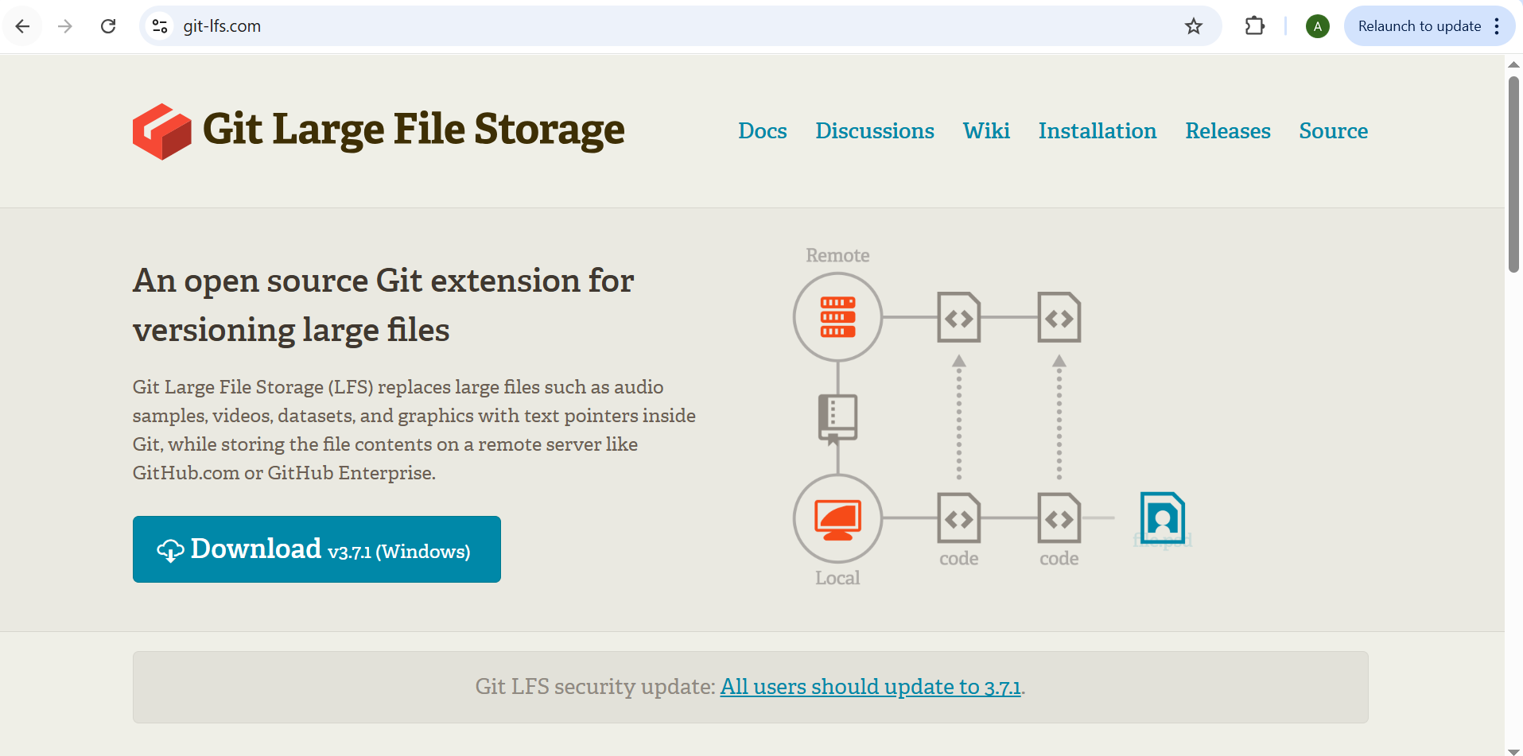

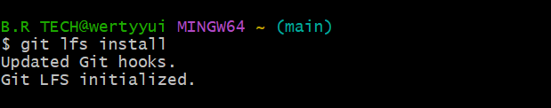

2. Add Large Files:

   - Add three files larger than 100 MB each to your repository.

 - Track them using Git LFS:

     git lfs track "*.ext"

Replace .ext with the appropriate file extension.

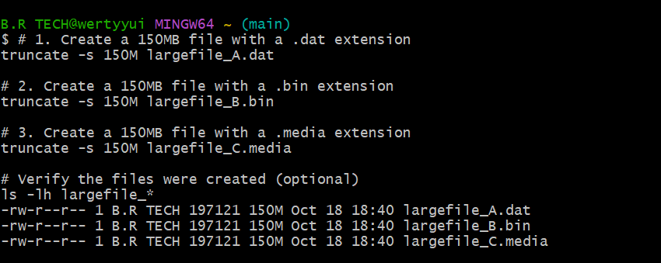

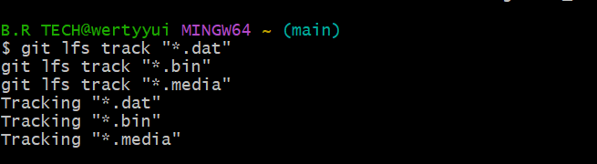

3. Reference in Assignment Repo:

   - Commit and push these large files to your GitHub assignment 1 repo.

   - Ensure the files are referenced correctly in your repository history. this is not linked to task 1 and 2 right?

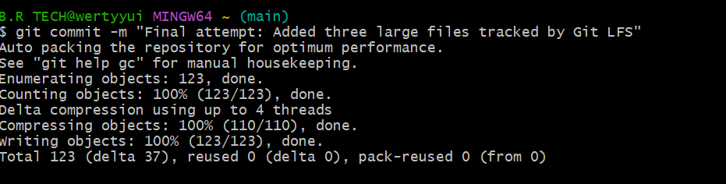

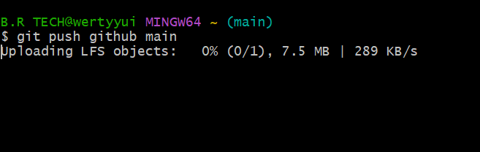

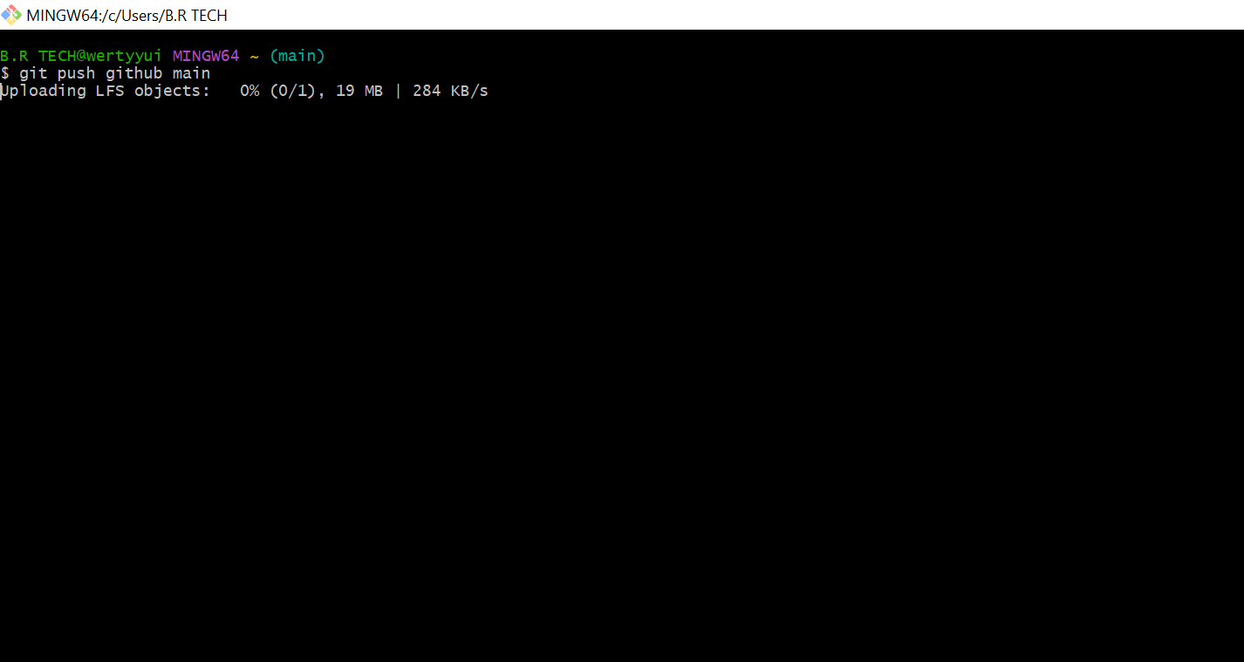

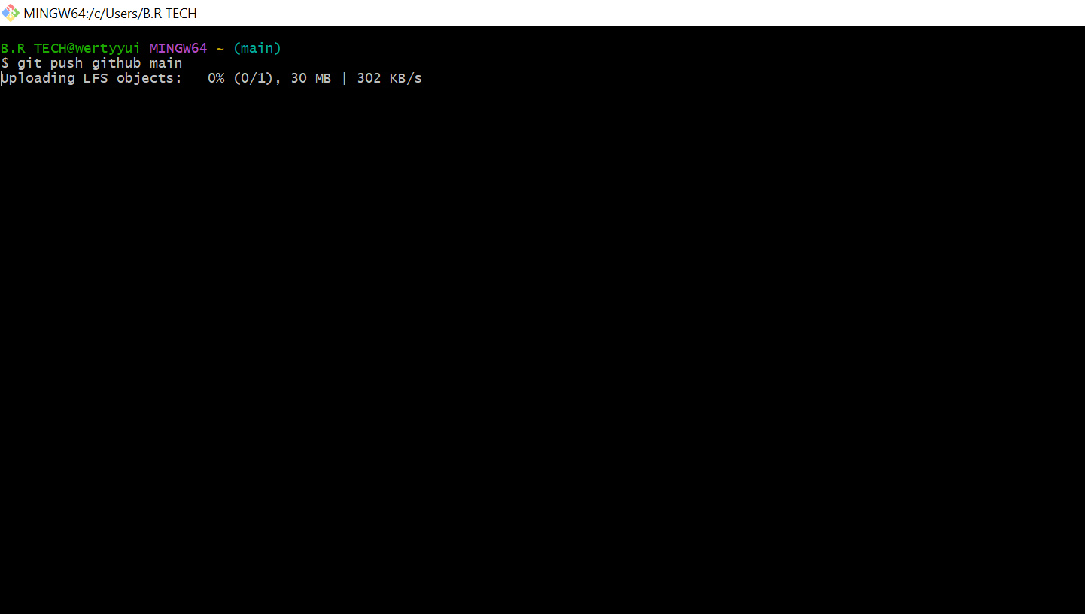

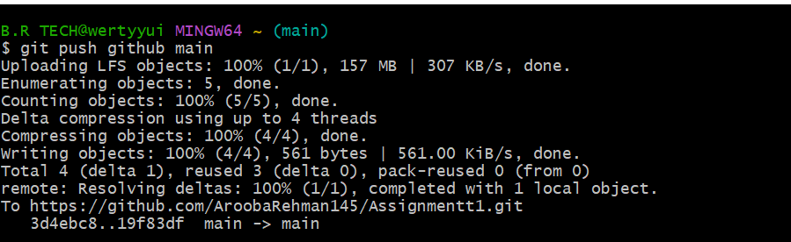

Task 4: Create a Portfolio/CV with GitHub Pages  
  
1. Create a new repository for GitHub Pages:  
   - Create a new repository named <your-username>.github.io.  
   - Replace <your-username> with your actual GitHub username (e.g., johnsmith.github.io).

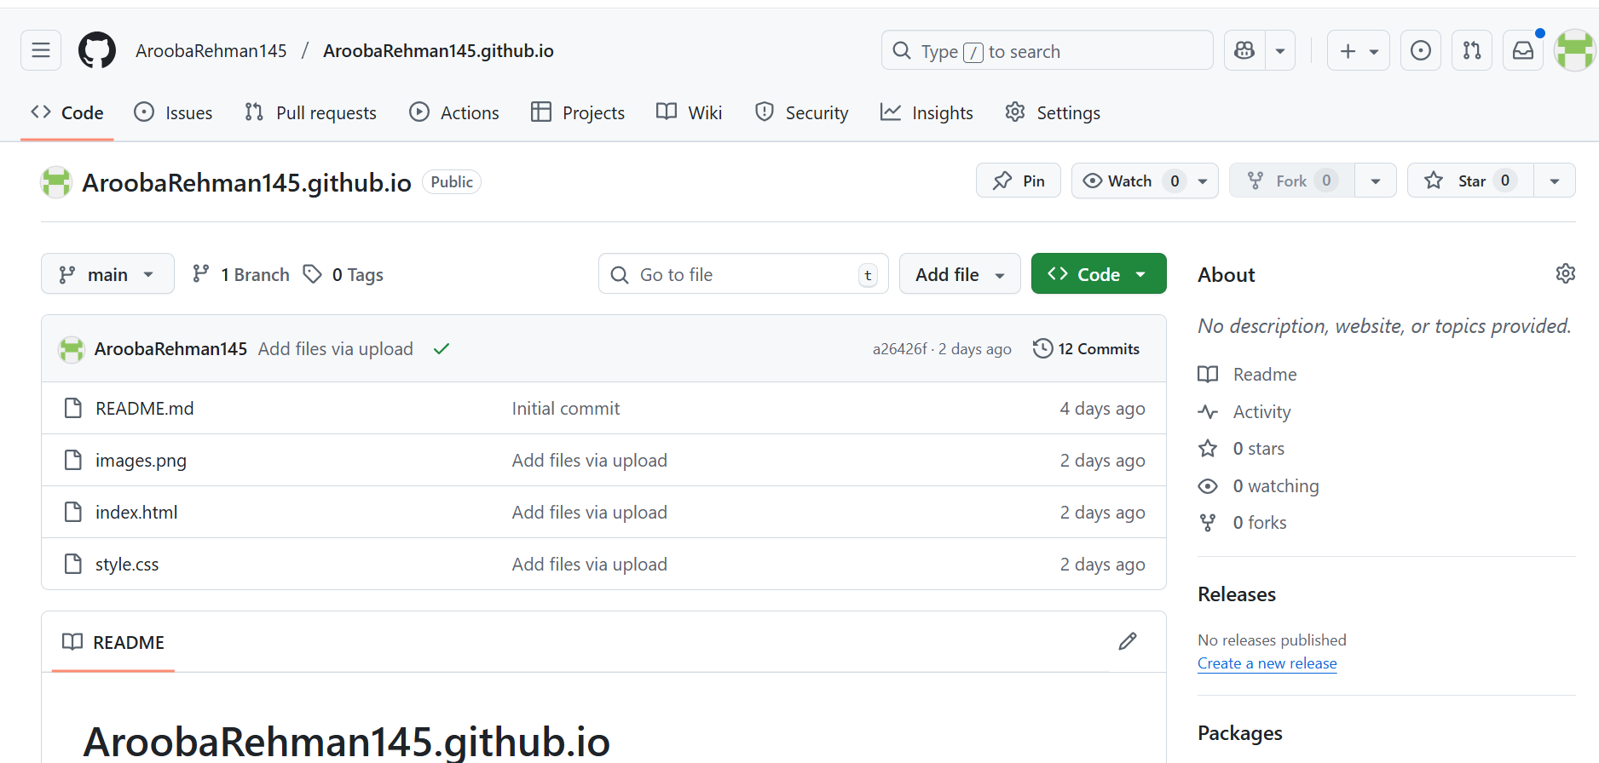

2. Design Your Portfolio/CV:  
   - Create your portfolio or CV in HTML/CSS (or use a static site generator).

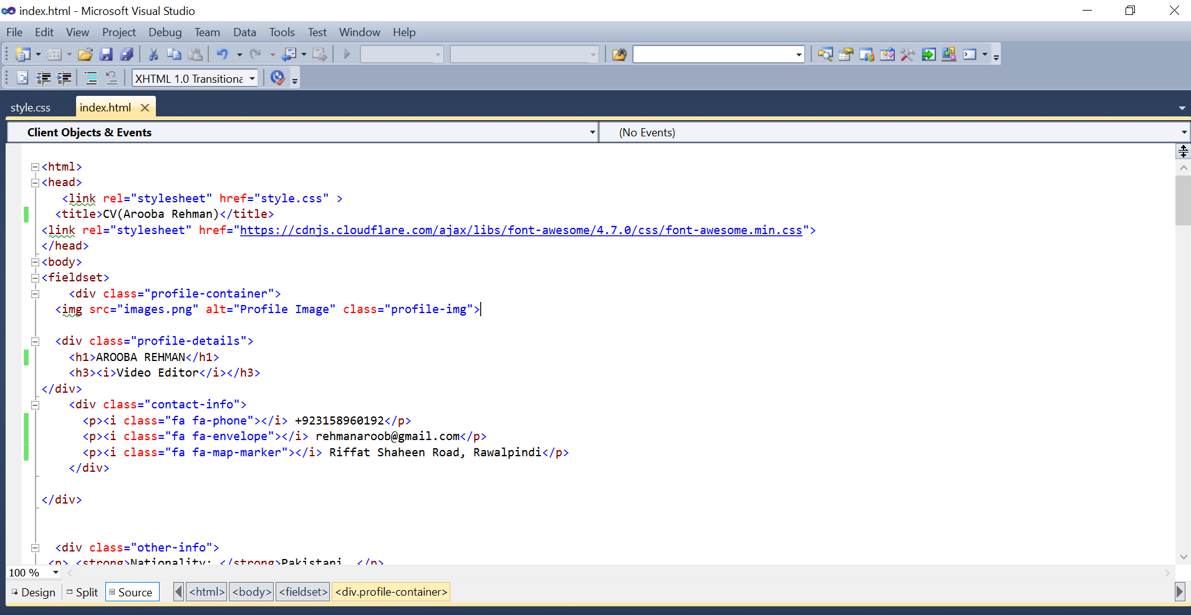

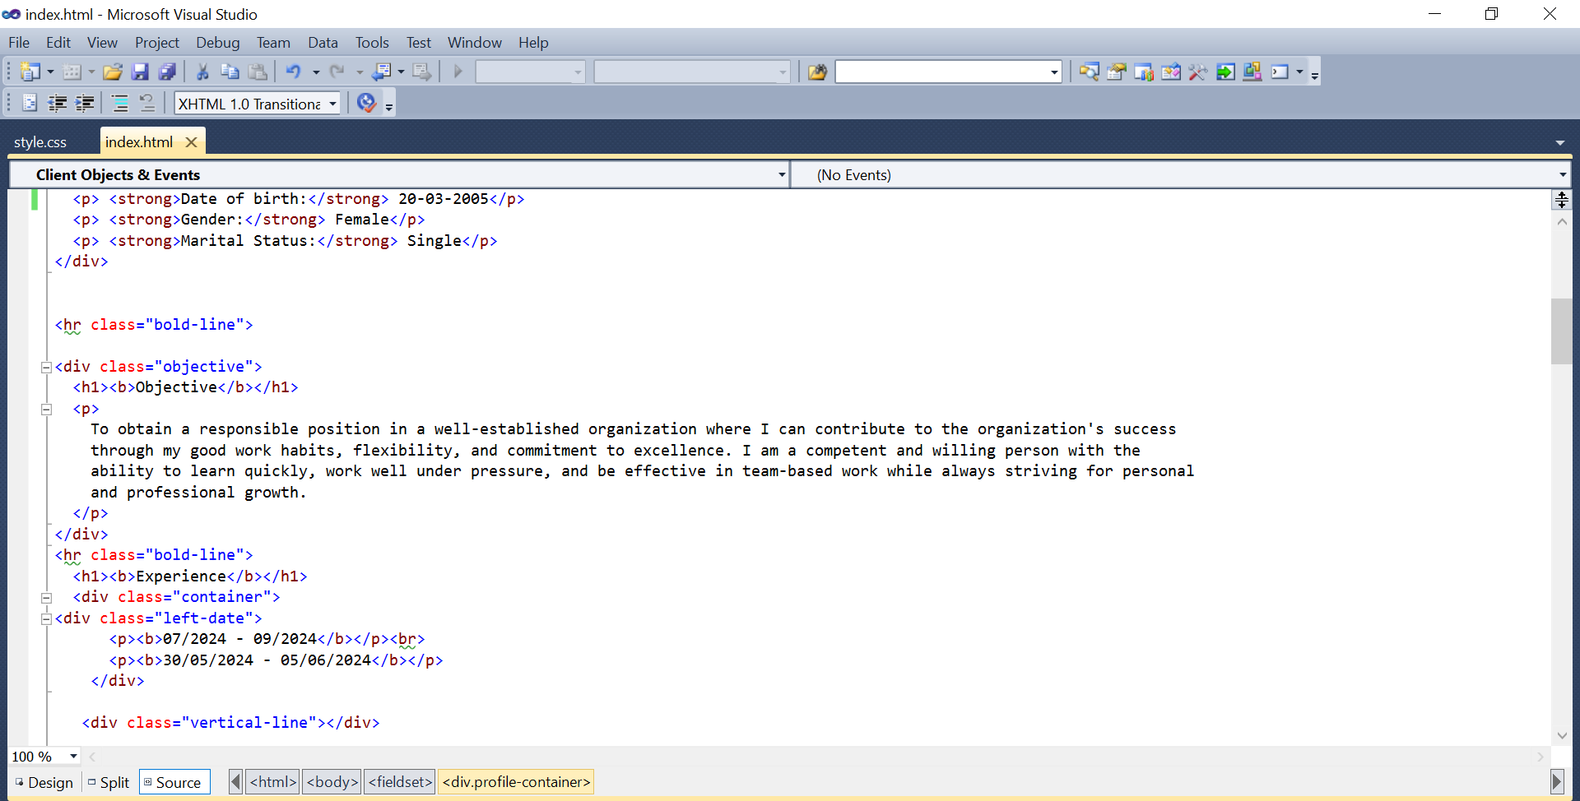

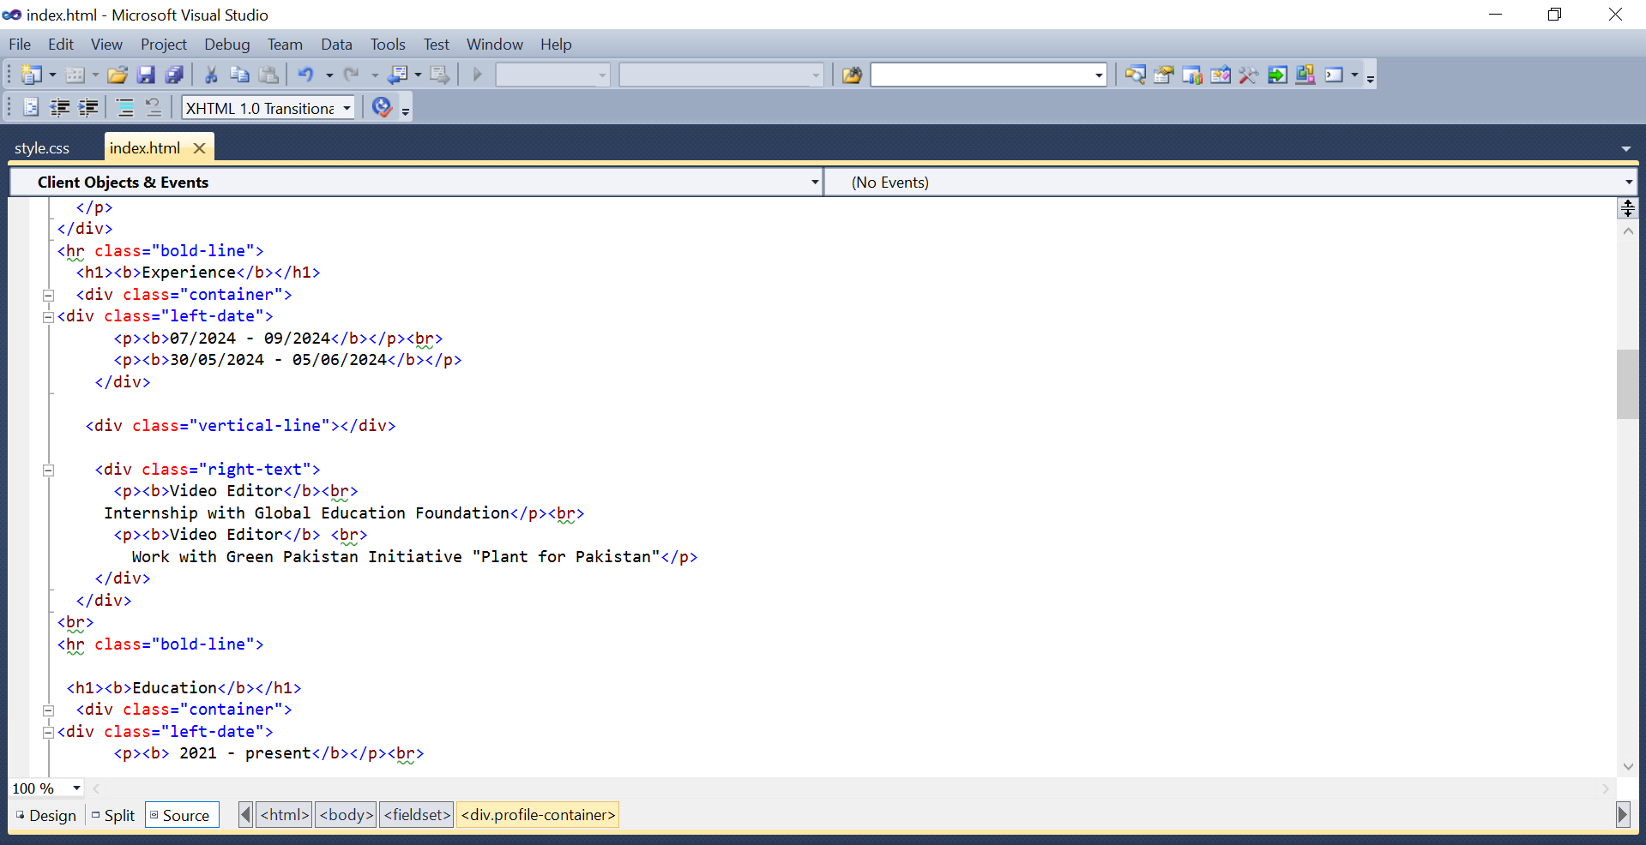

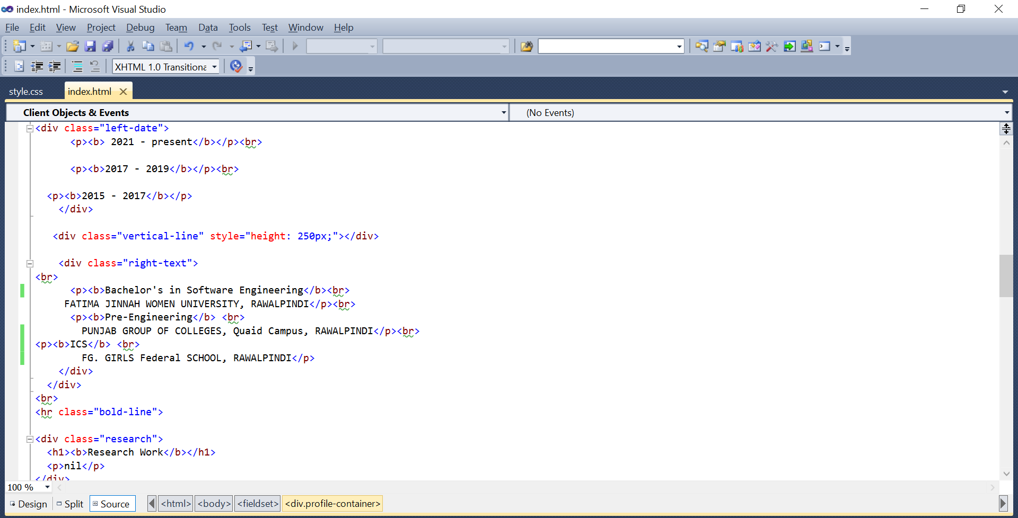

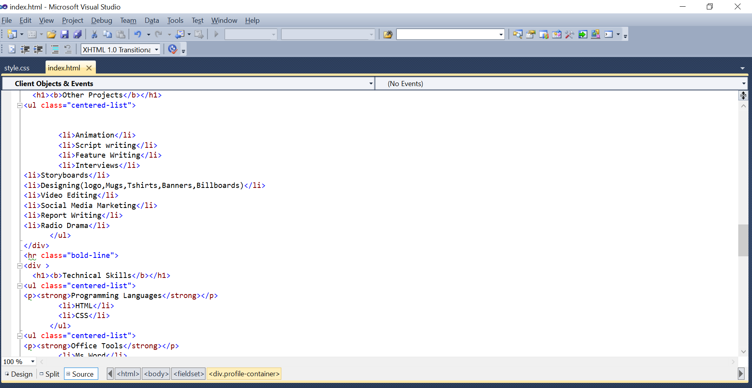

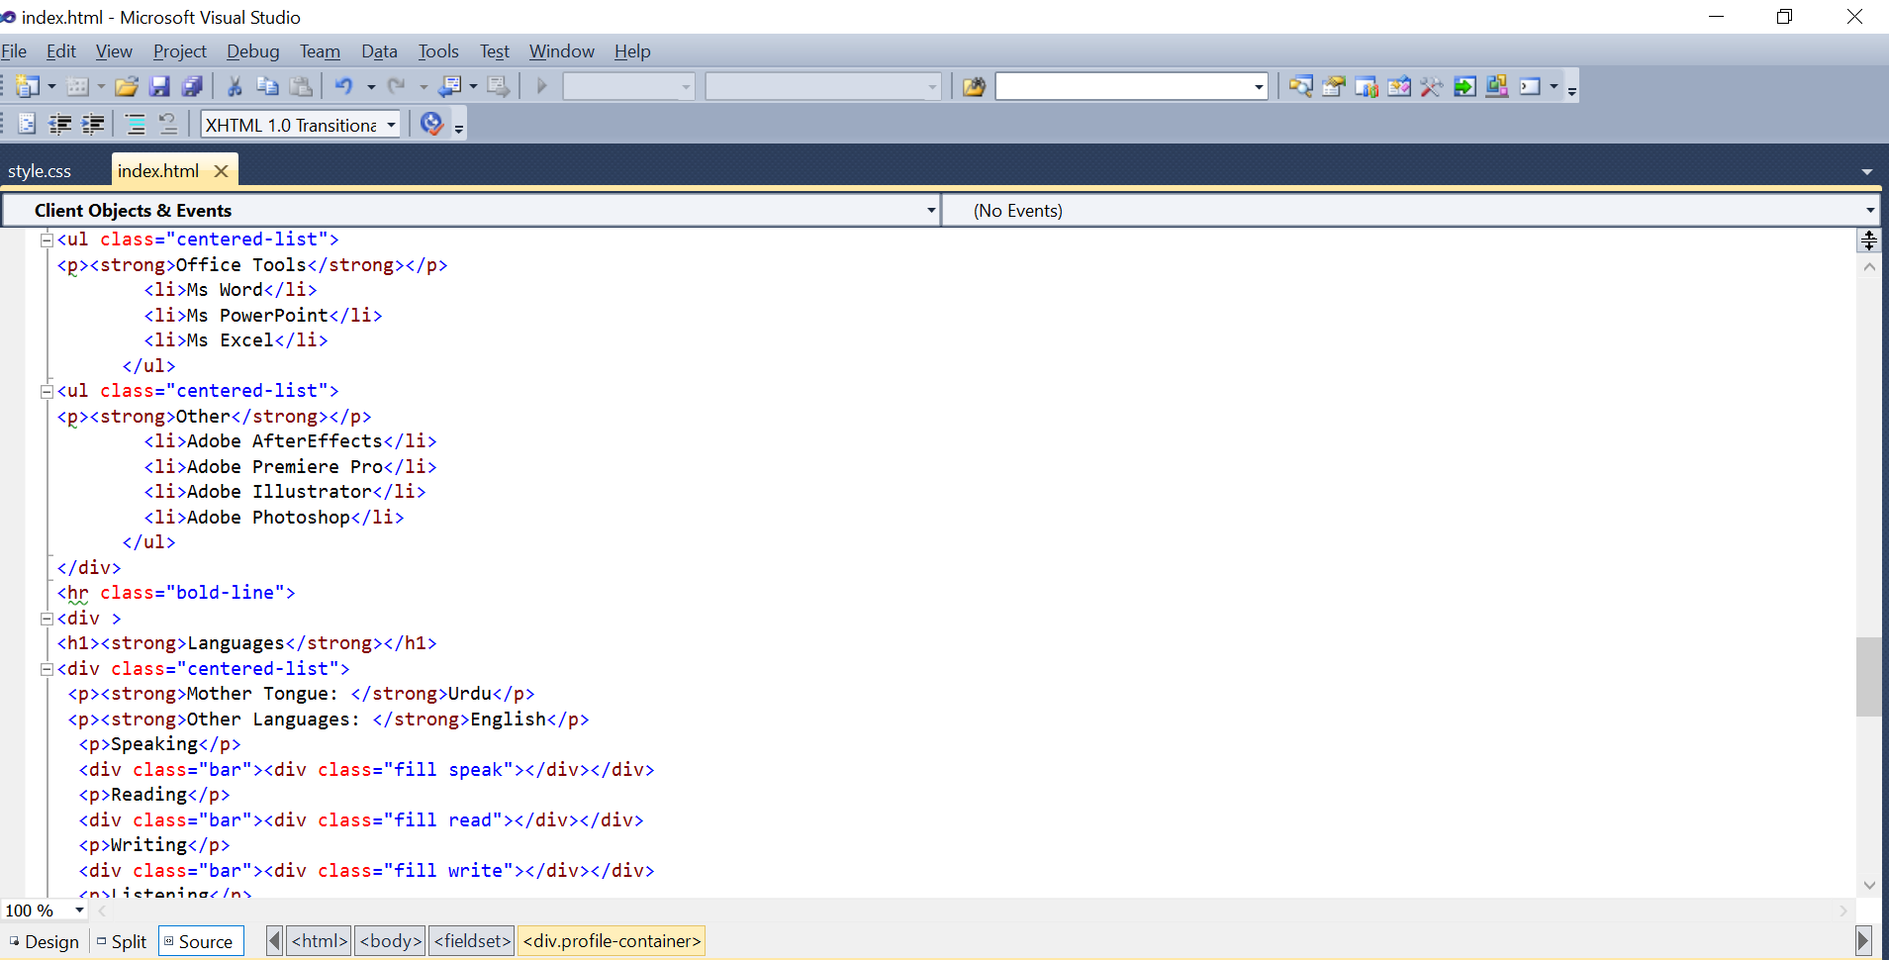

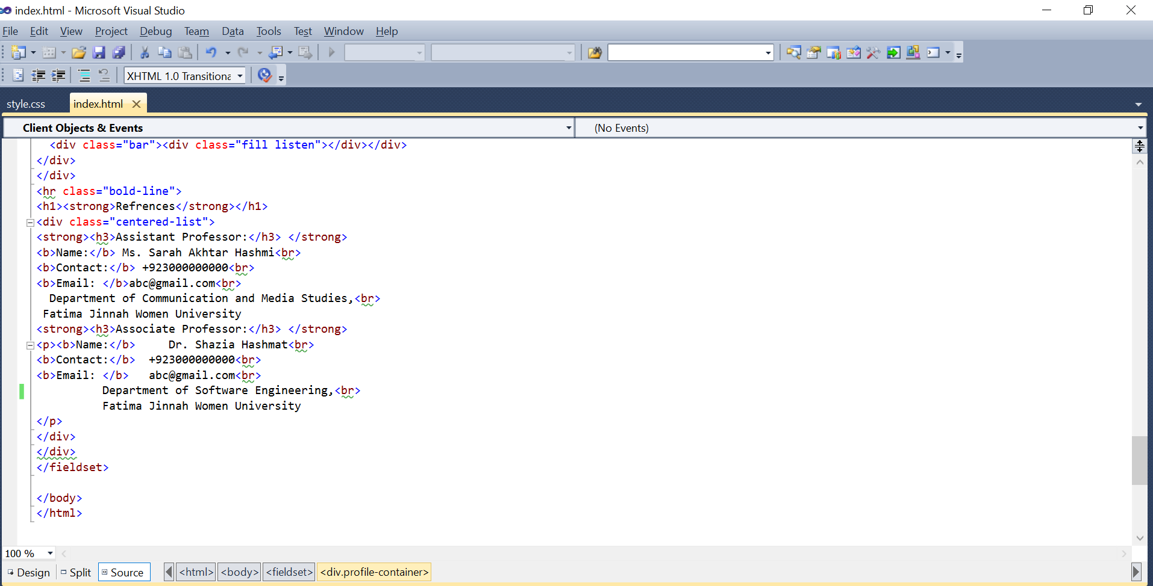

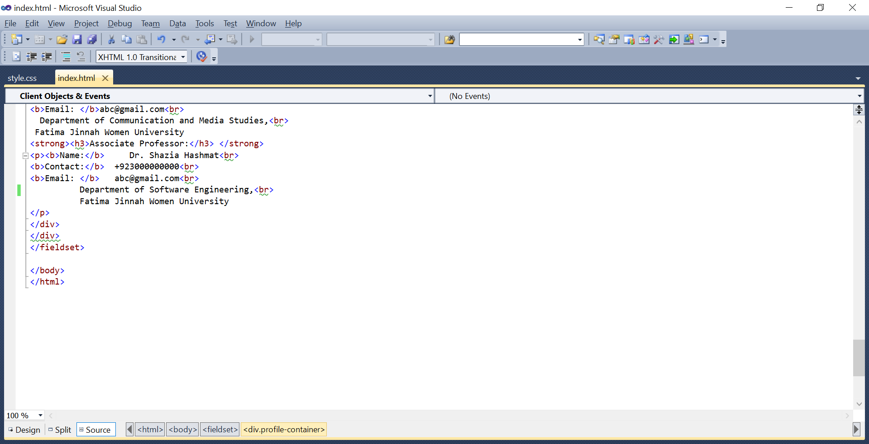

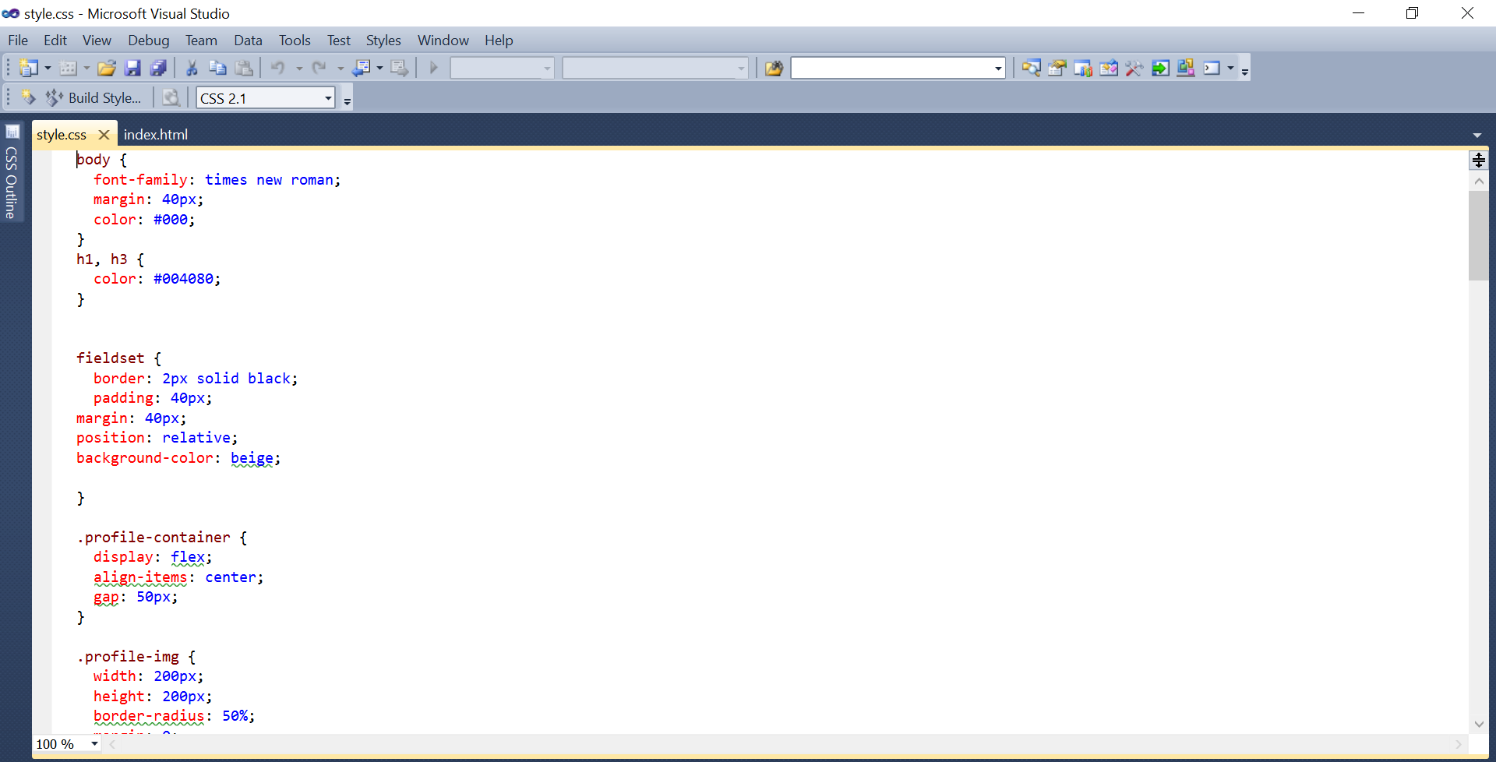

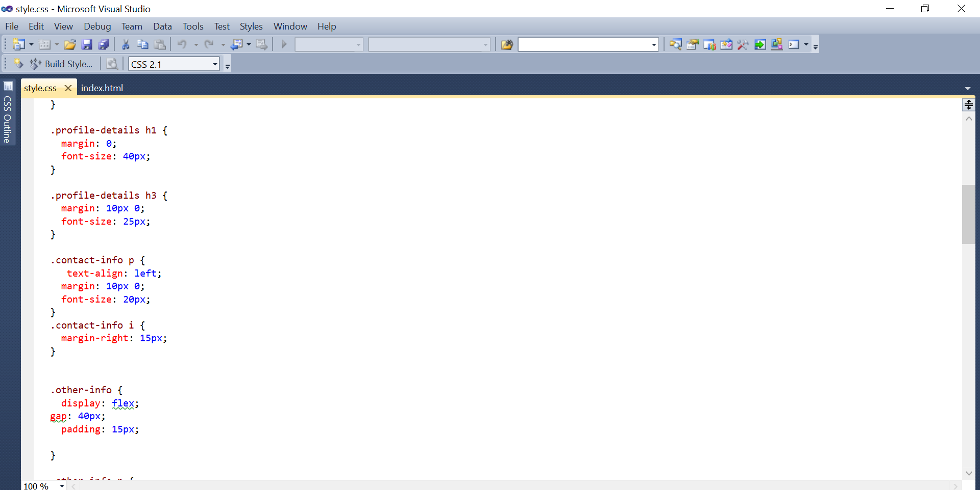

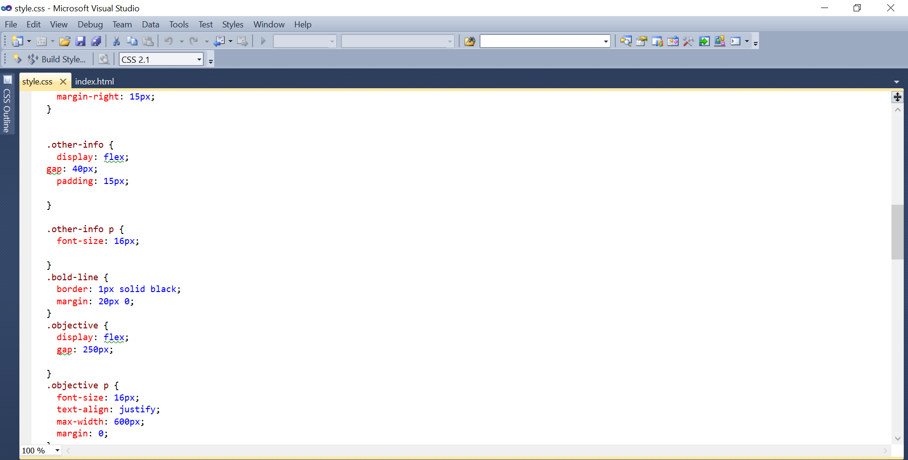

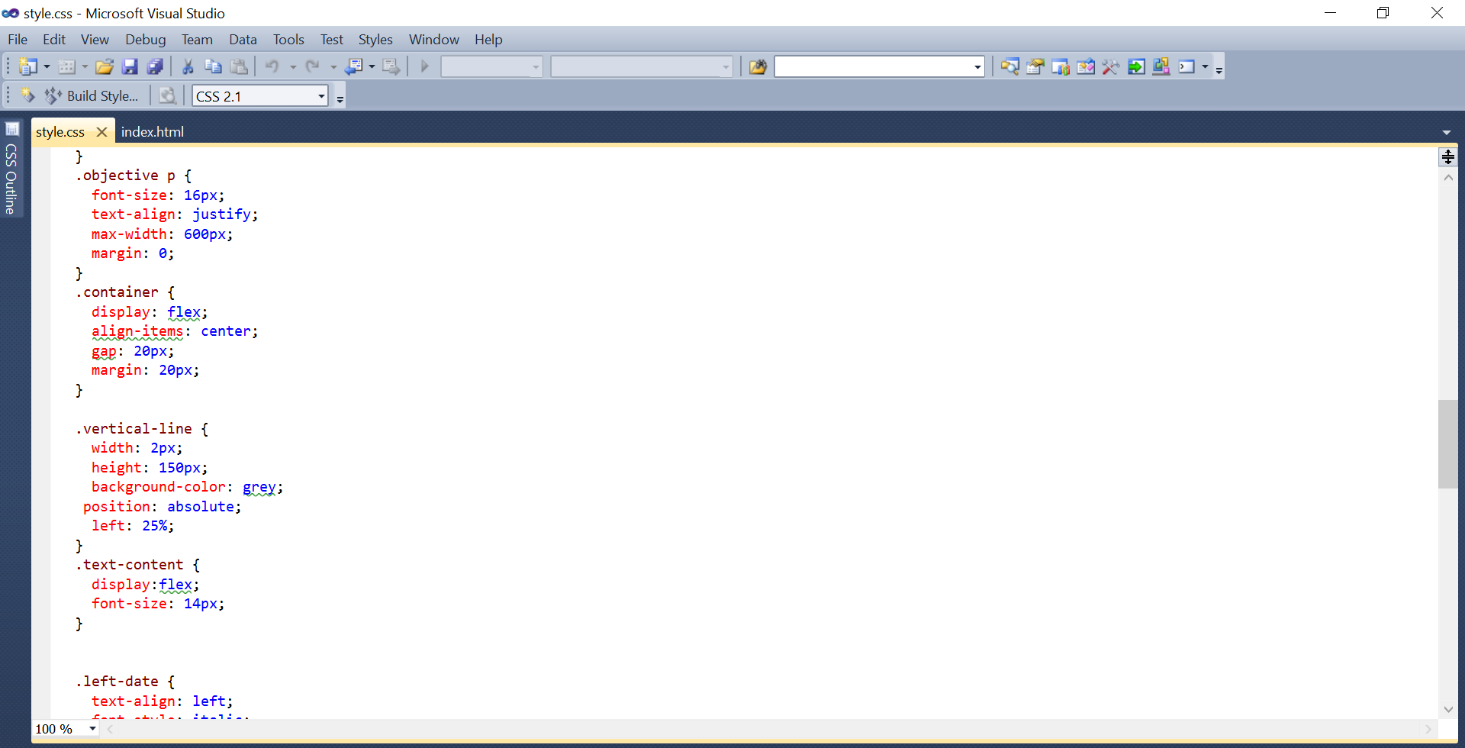

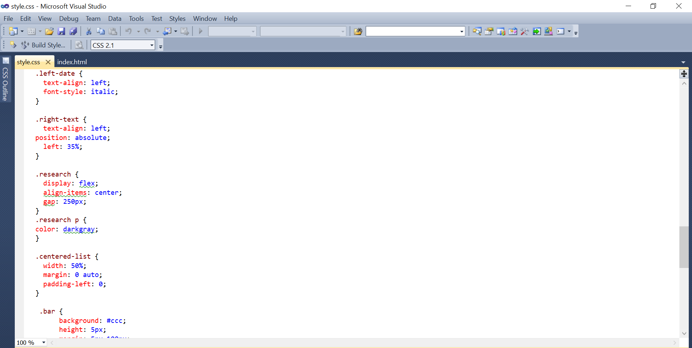

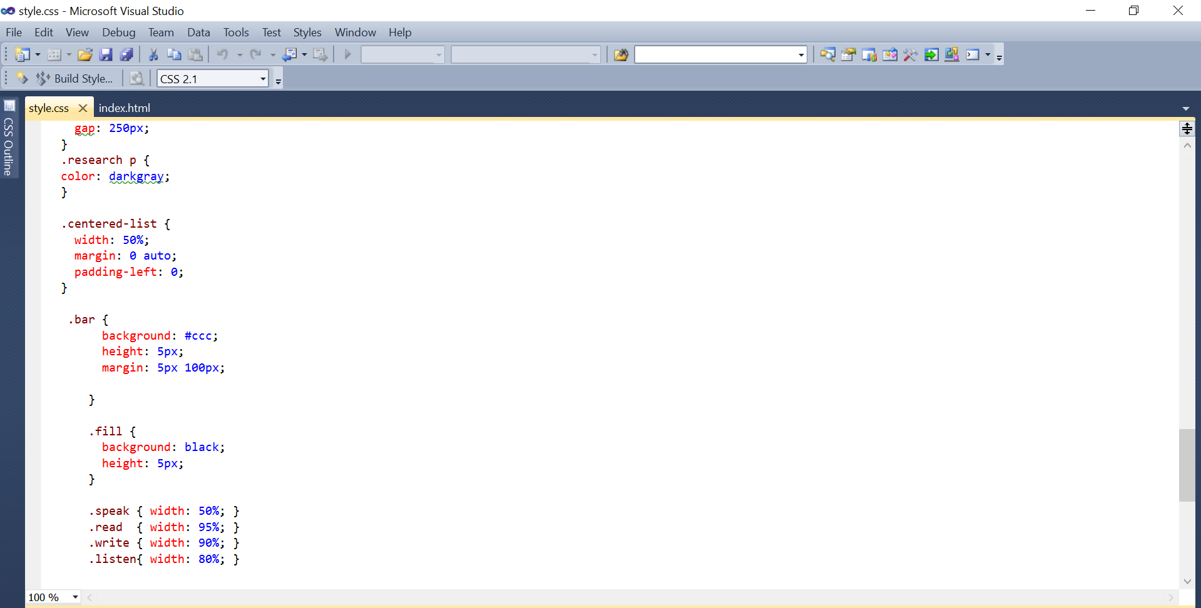

3. Publish with GitHub Pages:  
   - Push your portfolio/CV files to the <your-username>.github.io repository.

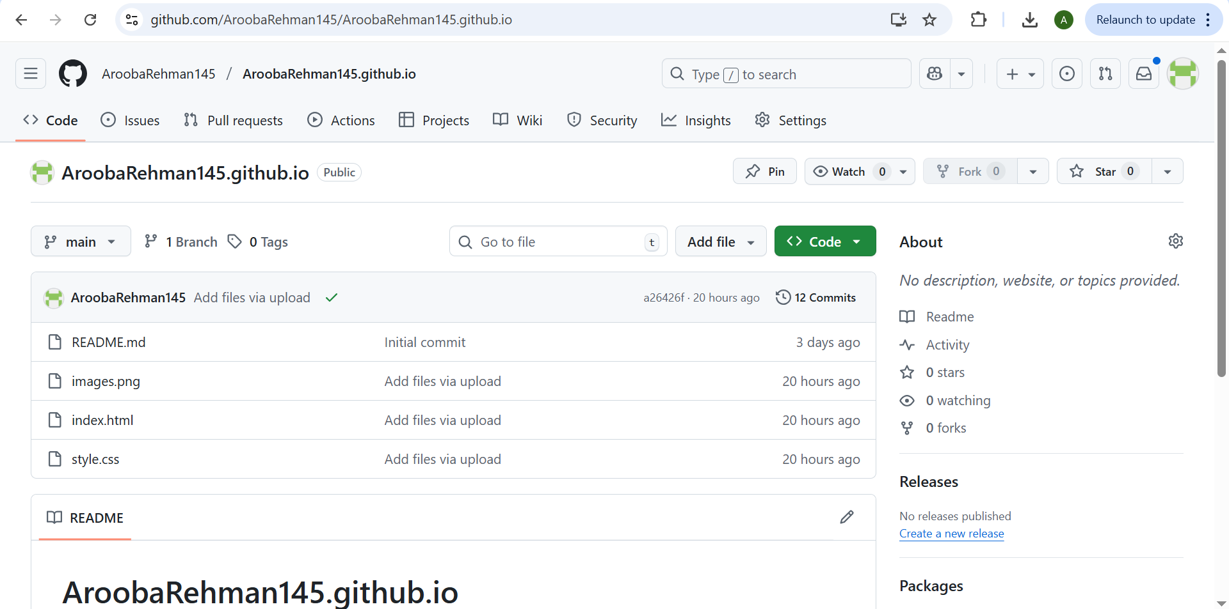

   - Enable GitHub Pages in your repository settings if not automatically enabled.  
   - Publish your site and share the link.

